MODULE – II
CLOUD COMPUTING ARCHITECTURE AND ANEKA

Introduction
Utility-oriented data centers are the first outcome of cloud computing, and they serve as the infrastructure through which the services are implemented and delivered. Commonly, clouds are built by relying on one or more datacenters. In most cases hardware resources are virtualized to provide isolation of workloads and to best exploit the infrastructure. According to the specific service delivered to the end user, different layers can be stacked on top of the virtual infrastructure: a virtual machine manager, a development platform, or a specific application middleware.
A broad definition of the phenomenon could be as follows:
“Cloud computing is a utility-oriented and Internet-centric way of delivering IT services on demand. These services cover the entire computing stack: from the hardware infrastructure packaged as a set of virtual machines to software services such as development platforms and distributed applications.”
The cloud reference model
Cloud computing supports any IT service that can be consumed as a utility and delivered through a network, most likely the Internet. Such characterization includes quite different aspects: infrastructure, development platforms, application and services.
Architecture
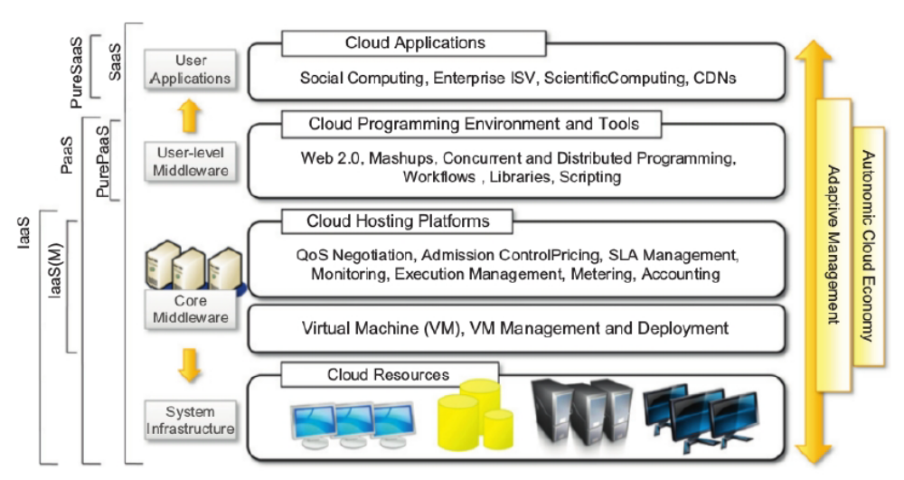
Figure 2.1: The cloud computing architecture
It is possible to organize all the concrete realizations of cloud computing into a layered view covering entire stack (see Figure 1.1), from hardware appliances to software systems. Cloud resources are harnessed to offer “computing horsepower” required for providing services. Cloud infrastructure can be heterogeneous in nature because a variety of resources, such as clusters and even networked PCs, can be used to build it.

The physical infrastructure is managed by the core middleware, the objectives of which are to provide an appropriate runtime environment for applications and to best utilize resources. At the bottom of the stack, virtualization technologies are used to guarantee runtime environment customization, application isolation, sandboxing, and quality of service. Hardware virtualization is most commonly used at this level.

Hypervisors manage the pool of resources and expose the distributed infrastructure as a collection of virtual machines. By using virtual machine technology it is possible to finely partition the hardware resources such as CPU and memory and to virtualize specific devices, thus meeting the requirements of users and applications. This solution is generally paired with storage and network virtualization strategies, which allow the infrastructure to be completely virtualized and controlled.

The combination of cloud hosting platforms and resources is generally classified as a Infrastructures-a-Service (IaaS) solution. We can organize the different examples of IaaS into two categories: Some of them provide both the management layer and the physical infrastructure; others provide only the management layer (IaaS (M)).

In this second case, the management layer is often integrated with other IaaS solutions that provide physical infrastructure and adds value to them. IaaS solutions are suitable for designing the system infrastructure but provide limited services to build applications. Such service is provided by cloud programming environments and tools, which form a new layer for offering users a development platform for applications.

The top layer of the reference model depicted in Figure 2.1 contains services delivered at the application level. These are mostly referred to as Software-as-a-Service (SaaS). In most cases these are Web-based applications that rely on the cloud to provide service to end users. The horsepower of the cloud provided by IaaS and PaaS solutions allows independent software vendors to deliver their application services over the Internet.
Table 1.1 summarizes the characteristics of the three major categories used to classify cloud computing solutions. In the following section, we briefly discuss these characteristics along with some references to practical implementations.
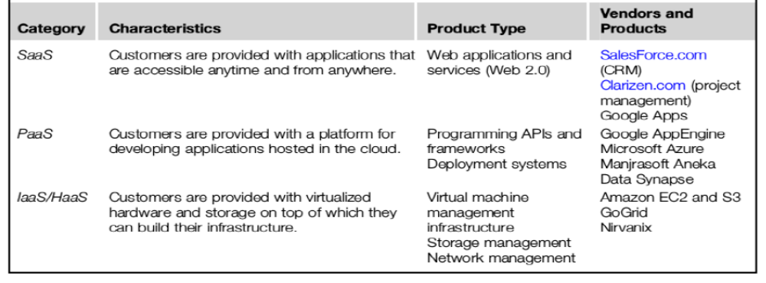Table 2.1: Cloud computing services classification

Infrastructure- and hardware-as-a-service
Infrastructure- and Hardware-as-a-Service (IaaS/HaaS) solutions are the most popular and developed market segment of cloud computing. They deliver customizable infrastructure on demand. The available options within the IaaS offering umbrella range from single servers to entire infrastructures, including network devices, load balancers, and database and Web servers.
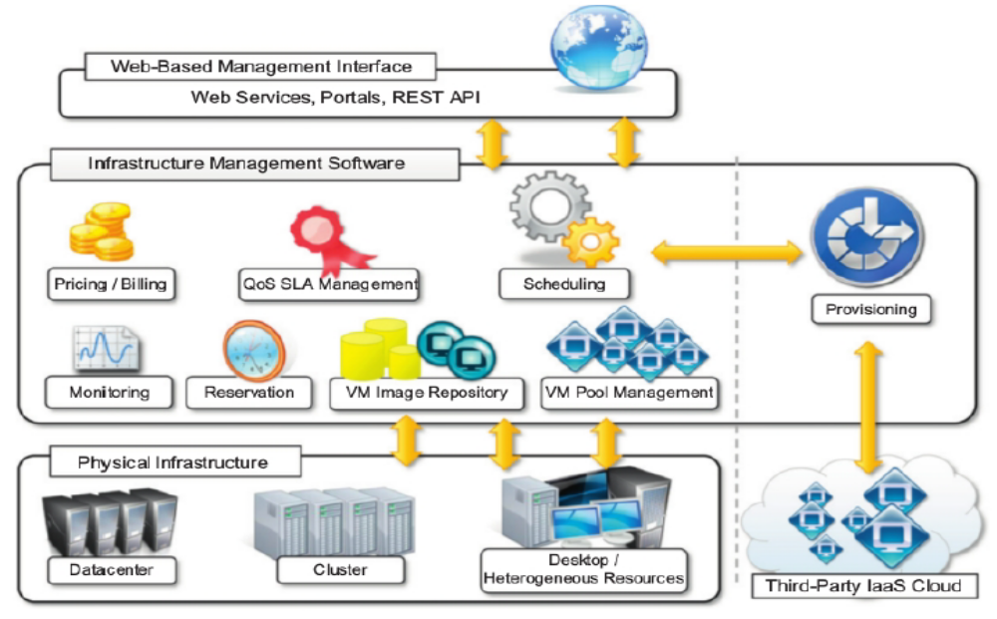
Figure 2.2: IaaS reference implementation
The main technology used to deliver and implement these solutions is hardware virtualization: one or more virtual machines opportunely configured and interconnected define the distributed system on top of which applications are installed and deployed. Virtual machines also constitute the atomic components that are deployed and priced according to the specific features of the virtual hardware: memory, number of processors, and disk storage. From the perspective of the customer it reduces the administration and maintenance cost as well as the capital costs allocated to purchase hardware.

Figure 2.2 provides an overall view of the components forming an Infrastructure-as-a-Service solution. It is possible to distinguish three principal layers: the physical infrastructure, the software management infrastructure, and the user interface. At the top layer the user interface provides access to the services exposed by the software management infrastructure. Such an interface is based on Web 2.0 technologies: Web services, RESTful APIs, and mash-ups.

These technologies allow either applications or final users to access the services exposed by the underlying infrastructure. Web 2.0 applications allow developing full featured management consoles completely hosted in a browser or a Web page. Web services and RESTful APIs allow programs to interact with the service without human intervention, thus providing complete integration within a software system.

A central role is played by the scheduler, which is in charge of allocating the execution of virtual machine instances. The scheduler interacts with the other components that perform a variety of tasks:
- The pricing and billing component takes care of the cost of executing each virtual machine instance and maintains data that will be used to charge the user.
- The monitoring component tracks the execution of each virtual machine instance and maintains data required for reporting and analyzing the performance of the system.
- The reservation component stores the information of all the virtual machine instances that have been executed or that will be executed in the future.

Platform as a service
Platform-as-a-Service (PaaS) solutions provide a development and deployment platform for running applications in the cloud. They constitute the middleware on top of which applications are built.
A general overview of the features characterizing the PaaS approach is given in Figure 2.3. Application management is the core functionality of the middleware. PaaS implementations provide applications with a runtime environment and do not expose any service for managing the underlying infrastructure. They automate the process of deploying applications to the infrastructure, configuring application components, provisioning and configuring supporting technologies such as load balancers and databases, and managing system change based on policies set by the user.
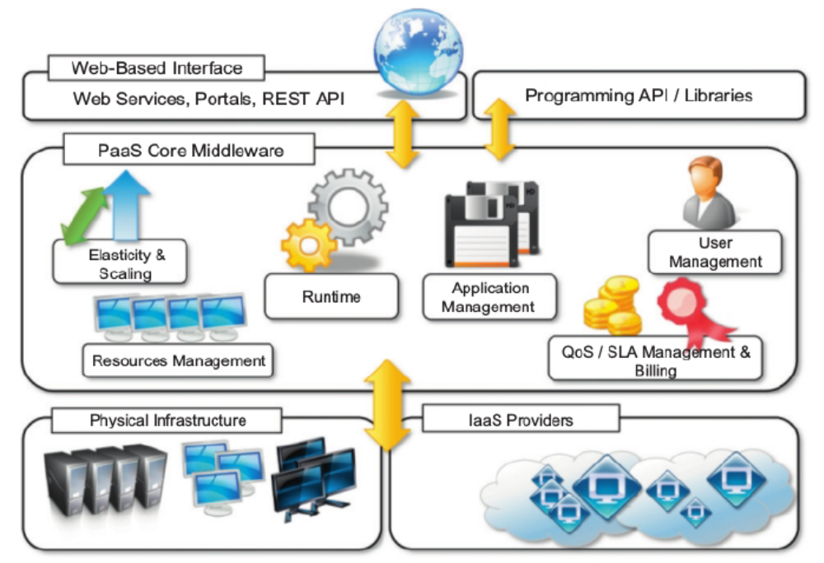
Figure 2.3: The PaaS reference model
The core middleware is in charge of managing the resources and scaling applications on demand or automatically, according to the commitments made with users. From a user point of view, the core middleware exposes interfaces that allow programming and deploying applications on the cloud. These can be in the form of a Web-based interface or in the form of programming APIs and libraries.

Table 2.2 provides a classification of the most popular PaaS implementations. It is possible to organize the various solutions into three wide categories: PaaS-I, PaaS-II, and PaaS-III. As noted by Sam Charrington, product manager at Appistry.com, there are some essential characteristics that identify a PaaS solution:
1. Runtime framework. This framework represents the “software stack” of the PaaS model. The runtime framework executes end-user code according to the policies set by the user and the provider.
2. Abstraction. PaaS solutions are distinguished by the higher level of abstraction that they provide. In the case of PaaS the focus is on the applications the cloud must support. PaaS solutions offer a way to deploy and manage applications on the cloud rather than a bunch of virtual machines on top of which the IT infrastructure is built and configured.
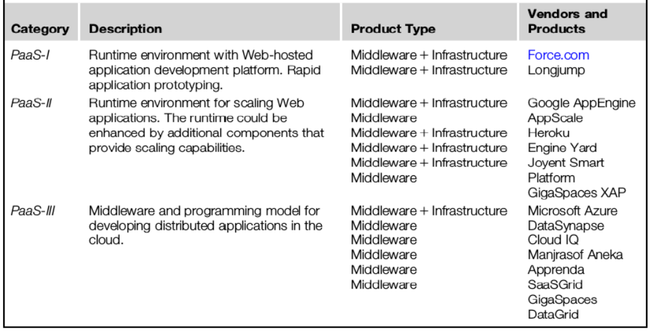Table 2.2: PaaS offering classification
3. Automation. PaaS environments automate the process of deploying applications to the infrastructure, scaling them by provisioning additional resources when needed. This process is performed automatically and according to the SLA made between the customers and the provider.
4. Cloud services. PaaS offerings provide developers and architects with services and APIs, helping them to simplify the creation and delivery of elastic and highly available cloud applications.

Software as a service
Software-as-a-Service (SaaS) is a software delivery model that provides access to applications through the Internet as a Web-based service. It provides a means to free users from complex hardware and software management by offloading such tasks to third parties, which build applications accessible to multiple users through a Web browser.
In this scenario, customers neither need install anything on their premises nor have to pay considerable up-front costs to purchase the software and the required licenses. The SaaS model is appealing for applications serving a wide range of users and that can be adapted to specific needs with little further customization.

This requirement characterizes SaaS as a “one-to many” software delivery model, whereby an application is shared across multiple users. This is the case of CRM 3 and ERP 4 applications that constitute common needs for almost all enterprises, from small to medium-sized and large business. Every enterprise will have the same requirements for the basic features concerning CRM and ERP; different needs can be satisfied with further customization.

ASPs (application service providers) has some of the core characteristics of SaaS:
• The product sold to customer is application access.
• The application is centrally managed.
• The service delivered is one-to-many.
• The service delivered is an integrated solution delivered on the contract, which means provided as promised.
The SaaS approach introduces a more flexible way of delivering application services that are fully customizable by the user by integrating new services, injecting their own components, and designing the application and information workflows.

The benefits delivered are the following:
1. Software cost reduction and total cost of ownership (TCO) were paramount
2. Service-level improvements
3. Rapid implementation
4. Standalone and configurable applications
5. Rudimentary application and data integration
6. Subscription and pay-as-you-go (PAYG) pricing

Types of clouds
Clouds constitute the primary outcome of cloud computing. They are a type of parallel and distributed system harnessing physical and virtual computers presented as a unified computing resource. A more useful classification is given according to the administrative domain of a cloud. It is then possible to differentiate four different types of cloud:
1. Public clouds. The cloud is open to the wider public.
2. Private clouds. The cloud is implemented within the private premises of an institution and generally made accessible to the members of the institution or a subset of them.
3. Hybrid or heterogeneous clouds. The cloud is a combination of the two previous solutions and most likely identifies a private cloud that has been augmented with resources or services hosted in a public cloud.
4. Community clouds. The cloud is characterized by a multi-administrative domain involving different deployment models (public, private, and hybrid), and it is specifically designed to address the needs of a specific industry.

Public clouds
Public clouds are a realization of the canonical view of cloud computing in which the services offered are made available to anyone, from anywhere, and at any time through the Internet. From a structural point of view they are a distributed system, most likely composed of one or more datacenters connected together, on top of which the specific services offered by the cloud are implemented. Any customer can easily sign in with the cloud provider, enter her credential and billing details, and use the services offered.

A fundamental characteristic of public clouds is multitenancy. A public cloud is meant to serve a multitude of users, not a single customer. Any customer requires a virtual computing environment that is separated, and most likely isolated, from other users. QoS management is a very important aspect of public clouds. Hence, a significant portion of the software infrastructure is devoted to monitoring the cloud resources, to bill them according to the contract made with the user, and to keep a complete history of cloud usage for each customer.

A public cloud can offer any kind of service: infrastructure, platform, or applications. For example,
Amazon EC2 is a public cloud that provides infrastructure as a service; Google AppEngine is a public cloud that provides an application development platform as a service; and SalesForce.com is a public cloud that provides software as a service.
Private cloud
Private clouds are virtual distributed systems that rely on a private infrastructure and provide internal users with dynamic provisioning of computing resources. Instead of a pay-as-you-go model as in public clouds, there could be other schemes in place, taking into account the usage of the cloud and proportionally billing the different departments or sections of an enterprise. Private clouds have the advantage of keeping the core business operations in-house by relying on the existing IT infrastructure and reducing the burden of maintaining it once the cloud has been set up. In this scenario, security concerns are less critical, since sensitive information does not flow out of the private infrastructure.
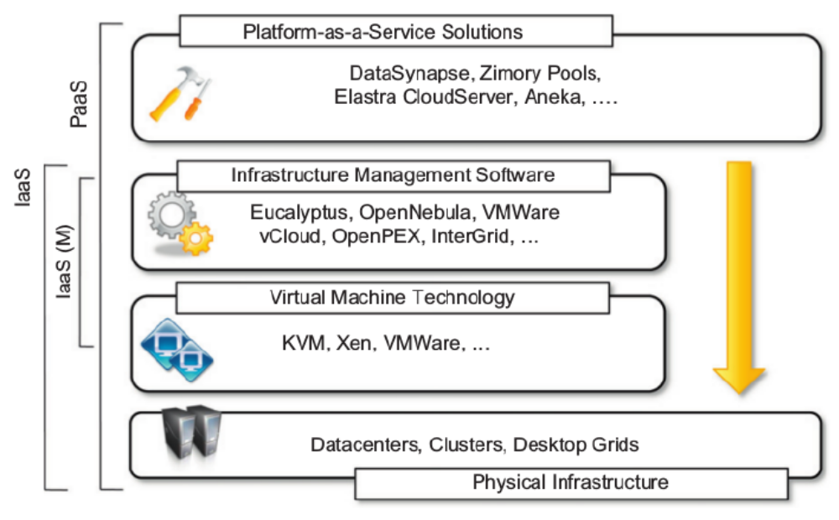
Figure 2.4: Private cloud hardware and software stack

Key advantages of using a private cloud computing infrastructure:
1. Customer information protection. Despite assurances by the public cloud leaders about security, few provide satisfactory disclosure or have long enough histories with their cloud offerings to provide warranties about the specific level of security put in place on their systems. In-house security is easier to maintain and rely on.

2. Infrastructure ensuring SLAs. Quality of service implies specific operations such as appropriate clustering and failover, data replication, system monitoring and maintenance, and disaster recovery, and other uptime services can be commensurate to the application needs. Although public cloud vendors provide some of these features, not all of them are available as needed.

3. Compliance with standard procedures and operations. If organizations are subject to third party compliance standards, specific procedures have to be put in place when deploying and executing applications. This could be not possible in the case of the virtual public infrastructure.

Hybrid clouds
Public clouds are large software and hardware infrastructures that have a capability that is huge enough to serve the needs of multiple users, but they suffer from security threats and administrative pitfalls. One of the major drawbacks of private deployments is the inability to scale on demand and to efficiently address peak loads. In this case, it is important to leverage capabilities of public clouds as needed.
Hybrid clouds allow enterprises to exploit existing IT infrastructures, maintain sensitive information within the premises, and naturally grow and shrink by provisioning external resources and releasing them when they’re no longer needed. Security concerns are then only limited to the public portion of the cloud that can be used to perform operations with less stringent constraints but that are still part of the system workload.

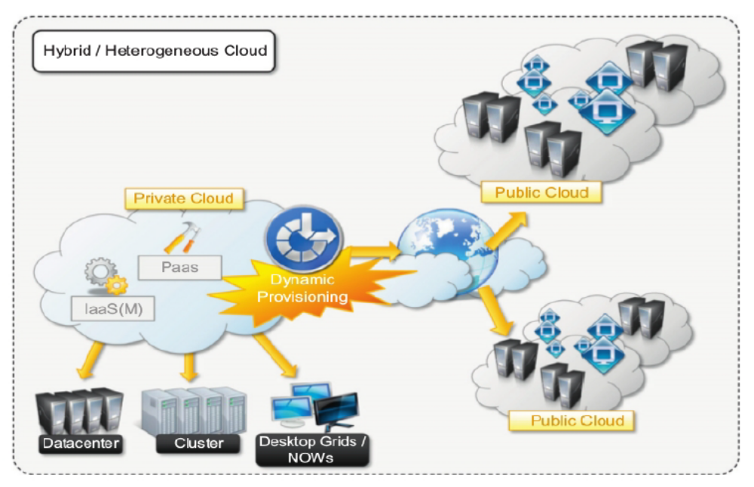
Figure 2.5: Hybrid cloud overview
Figure 2.5 provides a general overview of a hybrid cloud: It is a heterogeneous distributed system resulting from a private cloud that integrates additional services or resources from one or more public clouds. For this reason they are also called heterogeneous clouds. As depicted in the diagram, dynamic provisioning is a fundamental component in this scenario. Hybrid clouds address scalability issues by leveraging external resources for exceeding capacity demand. These resources or services are temporarily leased for the time required and then released. This practice is also known as cloud bursting.
Community clouds
Community clouds are distributed systems created by integrating the services of different clouds to address the specific needs of an industry, a community, or a business sector. The National Institute of Standards and Technologies (NIST) characterizes community clouds as follows:

“The infrastructure is shared by several organizations and supports a specific community that has shared concerns (e.g., mission, security requirements, policy, and compliance considerations). It may be managed by the organizations or a third party and may exist on premise or off premise.”

Figure 2.6 provides a general view of the usage scenario of community clouds, together with reference architecture. The users of a specific community cloud fall into a well-identified community, sharing the same concerns or needs; they can be government bodies, industries, or even simple users, but all of them focus on the same issues for their interaction with the cloud. This is a different scenario than public clouds, which serve a multitude of users with different needs. Community clouds are also different from private clouds, where the services are generally delivered within the institution that owns the cloud.
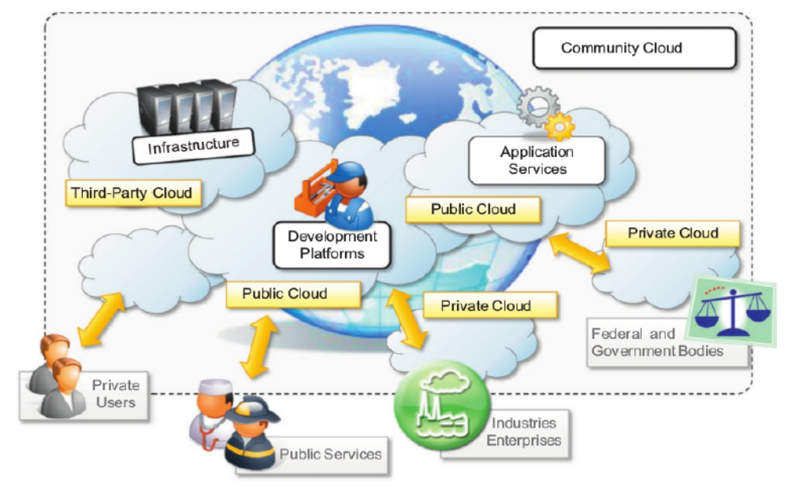
Figure 2.6: A community cloud

Candidate sectors for community clouds are as follows:
1. Media industry - looking for low-cost, agile, and simple solutions to improve the efficiency of content production.
2. Healthcare industry - In the healthcare industry, there are different scenarios in which community clouds could be of use. In particular, community clouds can provide a global platform on which to share information and knowledge without revealing sensitive data maintained within the private infrastructure.
3. Energy and other core industries - In these sectors, community clouds can bundle the comprehensive set of solutions that together vertically address management, deployment, and orchestration of services and operations.
4. Public sector - Legal and political restrictions in the public sector can limit the adoption of public cloud offerings. Moreover, governmental processes involve several institutions and agencies and are aimed at providing strategic solutions at local, national, and international administrative levels.
5. Scientific research - Science clouds are an interesting example of community clouds. In this case, the common interest driving different organizations sharing a large distributed infrastructure is scientific computing.

The benefits of these community clouds are the following:
1. Openness. By removing the dependency on cloud vendors, community clouds are open systems in which fair competition between different solutions can happen.
2. Community. Being based on a collective that provides resources and services, the infrastructure turns out to be more scalable because the system can grow simply by expanding its user base.
3. Graceful failures. Since there is no single provider or vendor in control of the infrastructure, there is no single point of failure.
4. Convenience and control. Within a community cloud there is no conflict between convenience and control because the cloud is shared and owned by the community, which makes all the decisions through a collective democratic process.
5. Environmental sustainability. The community cloud is supposed to have a smaller carbon footprint because it harnesses underutilized resources. Moreover, these clouds tend to be more organic by growing and shrinking in a symbiotic relationship to support the demand of the community, which in turn sustains it.
Economics of the cloud
The main drivers of cloud computing are economy of scale and simplicity of software delivery and its operation. In fact, the biggest benefit of this phenomenon is financial: the pay-as-you-go model offered by cloud providers. In particular, cloud computing allows:
1. Reducing the capital costs associated to the IT infrastructure
2. Eliminating the depreciation or lifetime costs associated with IT capital assets
3. Replacing software licensing with subscriptions
4. Cutting the maintenance and administrative costs of IT resources.

In terms of the pricing models introduced by cloud computing, we can distinguish three different strategies that are adopted by the providers:
1. Tiered pricing. In this model, cloud services are offered in several tiers, each of which offers a fixed computing specification and SLA at a specific price per unit of time. This model is used by Amazon for pricing the EC2 service.
2. Per-unit pricing. This model is more suitable to cases where the principal source of revenue for the cloud provider is determined in terms of units of specific services, such as data transfer and memory allocation. In this scenario customers can configure their systems more efficiently according to the application needs. This model is used, for example, by GoGrid, which makes customers pay according to RAM/hour units for the servers deployed in the GoGrid cloud.
3. Subscription-based pricing. This is the model used mostly by SaaS providers in which users pay a periodic subscription fee for use of the software or the specific component services that are integrated in their applications.

Open challenges
Cloud computing presents many challenges for industry and academia. There is a significant amount of work in academia focused on defining the challenges brought by this phenomenon.
In this section, we highlight the most important ones:
- Cloud definition
- Cloud interoperability and standards
- Scalability and fault tolerance
- Security, trust, and privacy
- Organizational aspects
Cloud definition
There have been several attempts made to define cloud computing and to provide a classification of all the services and technologies identified as such.
NSIT characterizes cloud computing as on-demand self-service, broad network access, resource pooling, rapid elasticity, and measured service; classifies services as SaaS, PaaS, and IaaS; and categorizes deployment models as public, private, community, and hybrid clouds. Alternative taxonomies for cloud services. David Linthicum, founder of BlueMountains Labs, provides a more detailed classification, which comprehends 10 different classes and better suits the vision of cloud computing within the enterprise.

Cloud interoperability and standards
To fully realize this goal, introducing standards and allowing interoperability between solutions offered by different vendors are objectives of fundamental importance. Vendor lock-in constitutes one of the major strategic barriers against the seamless adoption of cloud computing at all stages. The presence of standards that are actually implemented and adopted in the cloud computing community could give room for interoperability and then lessen the risks resulting from vendor lock-in.

The first steps toward a standardization process have been made, and a few organizations, such as the Cloud Computing Interoperability Forum (CCIF), the Open Cloud Consortium, and the DMTF Cloud Standards Incubator, are leading the path. Another interesting initiative is the Open Cloud Manifesto, which embodies the point of view of various stakeholders on the benefits of open standards in the field. The Open Virtualization Format (OVF) is an attempt to provide a common format for storing the information and metadata describing a virtual machine image.

Scalability and fault tolerance
The ability to scale on demand constitutes one of the most attractive features of cloud computing. Clouds allow scaling beyond the limits of the existing in-house IT resources, whether they are infrastructure (compute and storage) or applications services. To implement such a capability, the cloud middleware has to be designed with the principle of scalability along different dimensions in mind--for example, performance, size, and load. The cloud middleware manages a huge number of resource and users, which rely on the cloud to obtain the horsepower. In this scenario, the ability to tolerate failure becomes fundamental, sometimes even more important than providing an extremely efficient and optimized system.
Security, trust, and privacy
Security, trust, and privacy issues are major obstacles for massive adoption of cloud computing.
The traditional cryptographic technologies are used to prevent data tampering and access to sensitive information. The massive use of virtualization technologies exposes the existing system to new threats, which previously were not considered applicable.

Information can be stored within a cloud storage facility using the most advanced technology in cryptography to protect data and then be considered safe from any attempt to access it without the required permissions. The lack of control over data and processes also poses severe problems for the trust we give to the cloud service provider and the level of privacy we want to have for our data.
Organizational aspects
More precisely, storage, compute power, network infrastructure, and applications are delivered as metered services over the Internet. This introduces a billing model that is new within typical enterprise IT departments, which requires a certain level of cultural and organizational process maturity.
In particular, the following questions have to be considered:
1. What is the new role of the IT department in an enterprise that completely or significantly relies on the cloud?
2. How will the compliance department perform its activity when there is a considerable lack of control over application workflows?
3. What are the implications (political, legal, etc.) for organizations that lose control over some aspects of their services?
4. What will be the perception of the end users of such services?

Aneka
Cloud application platform
Aneka is Manjrasoft Pty. Ltd.’s solution for developing, deploying, and managing cloud applications. Aneka consists of a scalable cloud middleware that can be deployed on top of heterogeneous computing resources. It offers an extensible collection of services coordinating the execution of applications, helping administrators monitor the status of the cloud, and providing integration with existing cloud technologies.
One of Aneka’s key advantages is its extensible set of application programming interfaces (APIs) associated with different types of programming models—such as Task, Thread, and MapReduce—used for developing distributed applications, integrating new capabilities into the cloud, and supporting different types of cloud deployment models: public, private, and hybrid (see Figure 2.7).
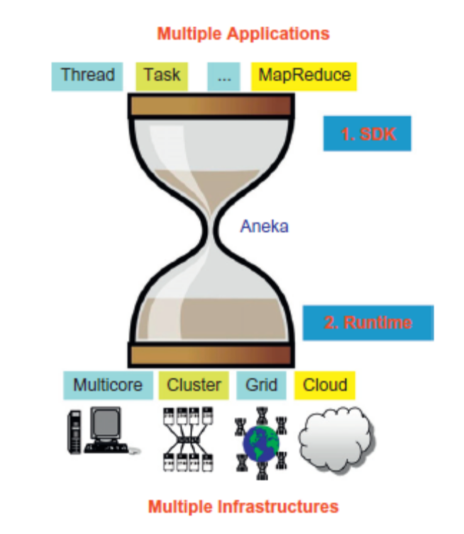
Figure 2.7: Aneka’s capabilities at a glance
Framework overview
Aneka is a software platform for developing cloud computing applications. It allows harnessing of disparate computing resources and managing them into a unique virtual domain--the Aneka Cloud—in which applications are executed. According to the Cloud Computing Reference Model presented in module 1, Aneka is a pure PaaS solution for cloud computing.
Aneka is a cloud mid dleware product that can be deployed on a heterogeneous set of resources: a network of computers, a multicore server, datacenters, virtual cloud infrastructures, or a mixture of these. The framework provides both middleware for managing and scaling distributed applications and an extensible set of APIs for developing them.
Figure 2.8 provides a complete overview of the components of the Aneka framework. The core infrastructure of the system provides a uniform layer that allows the framework to be deployed over different platforms and operating systems. The physical and virtual resources representing the bare metal of the cloud are managed by the Aneka container, which is installed on each node and constitutes the basic building block of the middleware.
The container features three different classes of services: Fabric Services, Foundation Services, and Execution Services. These take care of infrastructure management, supporting services for the Aneka Cloud, and application management and execution, respectively. These services are made available to developers and administrators by means of the application management and development layer, which includes interfaces and APIs for developing cloud applications and the management tools and interfaces for controlling Aneka Clouds.
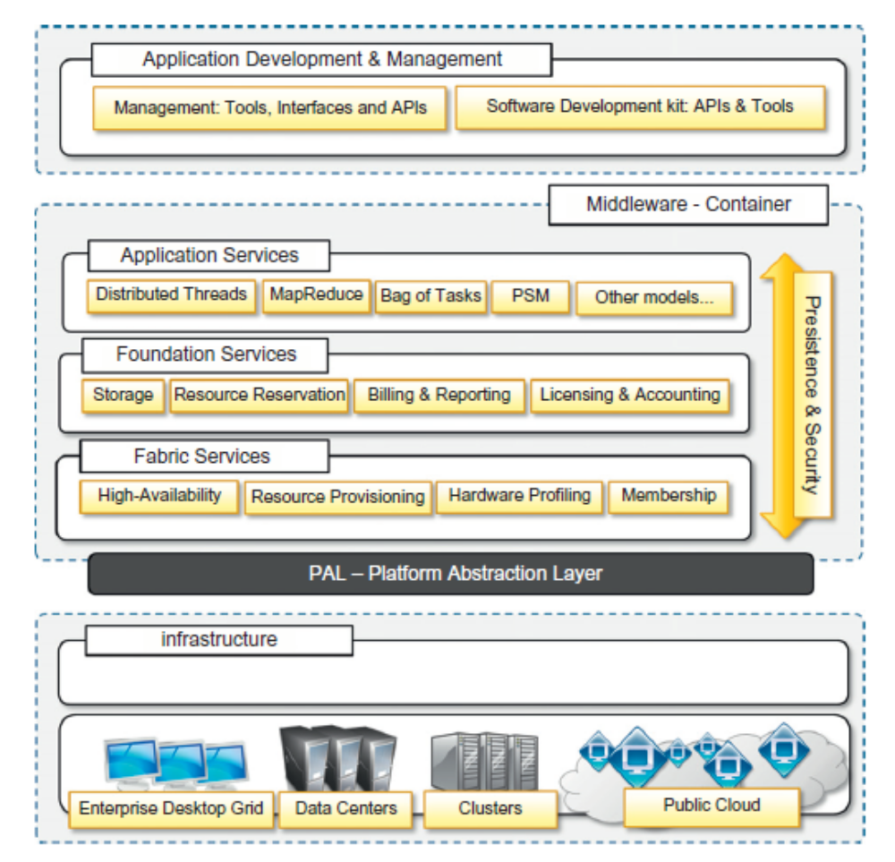
Figure 2.8: Aneka framework overview
Aneka implements a service-oriented architecture (SOA), and services are the fundamental components of an Aneka Cloud. Services operate at container level and, except for the platform abstraction layer, they provide developers, users, and administrators with all features offered by the framework. Services also constitute the extension and customization point of Aneka Clouds: The infrastructure allows for the integration of new services or replacement of the existing ones with a different implementation.
The framework includes the basic services for infrastructure and node management, application execution, accounting, and system monitoring; existing services can be extended and new features can be added to the cloud by dynamically plugging new ones into the container. Such extensible and flexible infrastructure enables Aneka Clouds to support different programming and execution models for applications.
Within an Aneka Cloud environment, there are different aspects involved in providing a scalable and elastic infrastructure and distributed runtime for applications. These services involve:
- Elasticity and Scaling: By means of the dynamic provisioning service, Aneka supports dynamically upsizing and downsizing of the infrastructure available for applications.
- Runtime management: The runtime machinery is responsible for keeping the infrastructure up and running and serves as a hosting environment for services. It is primarily represented by the container and a collection of services that manage service membership and lookup, infrastructure maintenance, and profiling.
- Resource management: Aneka is an elastic infrastructure in which resources are added and removed dynamically according to application needs and user requirements. To provide QoS-based execution, the system not only allows dynamic provisioning but also provides capabilities for reserving nodes for exclusive use by specific applications.
- Application management: A specific subset of services is devoted to managing applications. These services include scheduling, execution, monitoring, and storage management.
- User management: Aneka is a multitenant distributed environment in which multiple applications, potentially belonging to different users, are executed. The framework provides an extensible user system via which it is possible to define users, groups, and permissions. The services devoted to user management build up the security infrastructure of the system and constitute a fundamental element for accounting management.
- QoS/SLA management and billing: Within a cloud environment, application execution is metered and billed. Aneka provides a collection of services that coordinate together to take into account the usage of resources by each application and to bill the owning user accordingly.

Anatomy of the Aneka container
The Aneka container constitutes the building blocks of Aneka Clouds and represents the runtime machinery available to services and applications. The container, the unit of deployment in Aneka Clouds, is a lightweight software layer designed to host services and interact with the underlying operating system and hardware. The main role of the container is to provide a lightweight environment in which to deploy services and some basic capabilities such as communication channels through which it interacts with other nodes in the Aneka Cloud.

Almost all operations performed within Aneka are carried out by the services managed by the container. The services installed in the Aneka container can be classified into three major categories:
- Fabric Services
- Foundation Services
- Application Services
From the ground up: the platform abstraction layer
The core infrastructure of the system is based on the .NET technology and allows the Aneka container to be portable over different platforms and operating systems. Any platform featuring an ECMA-334 and ECMA-335 compatible environment can host and run an instance of the Aneka container. The Common Language Infrastructure (CLI), which is the specification introduced in the ECMA-334 standard, defines a common runtime environment and application model for executing programs but does not provide any interface to access the hardware or to collect performance data from the hosting operating system. Moreover, each operating system has a different file system organization and stores that information differently.

The PAL is responsible for detecting the supported hosting environment and providing the cor- responding implementation to interact with it to support the activity of the container. The PAL pro- vides the following features:
- Uniform and platform-independent implementation interface for accessing the hosting platform
- Uniform access to extended and additional properties of the hosting platform
- Uniform and platform-independent access to remote nodes
- Uniform and platform-independent management interfaces

The PAL is a small layer of software that comprises a detection engine, which automatically configures the container at boot time, with the platform-specific component to access the above information and an implementation of the abstraction layer for the Windows, Linux, and Mac OS X operating systems.
The collectible data that are exposed by the PAL are the following:
Number of cores, frequency, and CPU usage
- Memory size and usage
- Aggregate available disk space
- Network addresses and devices attached to the node
Fabric services
Fabric Services define the lowest level of the software stack representing the Aneka Container. They provide access to the resource-provisioning subsystem and to the monitoring facilities implemented in Aneka. Resource-provisioning services are in charge of dynamically providing new nodes on demand by relying on virtualization technologies, while monitoring services allow for hardware profiling and implement a basic monitoring infrastructure that can be used by all the services installed in the container.
Profiling and monitoring
Profiling and monitoring services are mostly exposed through the Heartbeat, Monitoring, and Reporting Services. The first makes available the information that is collected through the PAL; the other two implement a generic infrastructure for monitoring the activity of any service in the Aneka Cloud. The Heartbeat Service periodically collects the dynamic performance information about the node and publishes this information to the membership service in the Aneka Cloud.

These data are collected by the index node of the Cloud, which makes them available for services such as reservations and scheduling in order to optimize the use of a heterogeneous infrastructure. As already dis- cussed, basic information about memory, disk space, CPU, and operating system is collected. Moreover, additional data are pulled into the “alive” message, such as information about the installed software in the system and any other useful information.

The set of built-in services for monitoring and profiling is completed by a generic monitoring infrastructure, which allows any custom service to report its activity. This infrastructure is com- posed of the Reporting and Monitoring Services. The Reporting Service manages the store for monitored data and makes them accessible to other services or external applications for analysis purposes.

On each node, an instance of the Monitoring Service acts as a gateway to the Reporting Service and forwards to it all the monitored data that has been collected on the node. Any service that wants to publish monitoring data can leverage the local monitoring service without knowing the details of the entire infrastructure. Currently several built in services provide information through this channel:
- The Membership Catalogue tracks the performance information of nodes.
- The Execution Service monitors several time intervals for the execution of jobs.
- The Scheduling Service tracks the state transitions of jobs.
- The Storage Service monitors and makes available information about data transfer, such as upload and download times, filenames, and sizes.
- The Resource Provisioning Service tracks the provisioning and lifetime information of virtual nodes.
Resource management
Resource management is another fundamental feature of Aneka Clouds. It comprises several tasks: resource membership, resource reservation, and resource provisioning. Aneka provides a collection of services that are in charge of managing resources. These are the Index Service (or Membership Catalogue), Reservation Service, and Resource Provisioning Service.

The Membership Catalogue is Aneka’s fundamental component for resource management; it keeps track of the basic node information for all the nodes that are connected or disconnected. The Membership Catalogue implements the basic services of a directory service, allowing the search for services using attributes such as names and nodes. During container startup, each instance publishes its information to the Membership Catalogue and updates it constantly during its lifetime. Services and external applications can query the membership catalogue to discover the available services and interact with them.

To speed up and enhance the performance of queries, the membership catalogue is organized as a distributed database: All the queries that pertain to information maintained locally are resolved locally; otherwise the query is forwarded to the main index node, which has a global knowledge of the entire Cloud.

Dynamic resource provisioning allows the integration and management of virtual resources leased from IaaS providers into the Aneka Cloud. This service changes the structure of the Aneka Cloud by allowing it to scale up and down according to different needs: handling node failures, ensuring the quality of service for applications, or maintaining a constant performance and throughput of the Cloud. Aneka defines a very flexible infrastructure for resource provisioning whereby it is possible to change the logic that triggers provisioning, support several back-ends, and change the runtime strategy with which a specific back-end is selected for provisioning.

Resource provisioning is a feature designed to support QoS requirements-driven execution of applications. Therefore, it mostly serves requests coming from the Reservation Service or the Scheduling Services. Despite this, external applications can directly leverage Aneka’s resource- provisioning capabilities by dynamically retrieving a client to the service and interacting with the infrastructure to it.

Foundation services
Fabric Services are fundamental services of the Aneka Cloud and define the basic infrastructure management features of the system. Foundation Services are related to the logical management of the distributed system built on top of the infrastructure and provide supporting services for the execution of distributed applications.

All the supported programming models can integrate with and leverage these services to provide advanced and comprehensive application management. These services cover:
- Storage management for applications
- Accounting, billing, and resource pricing
- Resource reservation
Foundation Services provide a uniform approach to managing distributed applications and allow developers to concentrate only on the logic that distinguishes a specific programming model from the others. Together with the Fabric Services, Foundation Services constitute the core of the Aneka middleware.
Storage management
Data management is an important aspect of any distributed system, even in computing clouds. Applications operate on data, which are mostly persisted and moved in the format of files. Hence, any infrastructure that supports the execution of distributed applications needs to provide facilities for file/data transfer management and persistent storage. Aneka offers two different facilities for storage management: a centralized file storage, which is mostly used for the execution of compute- intensive applications, and a distributed file system, which is more suitable for the execution of data-intensive applications.

Centralized storage is implemented through and managed by Aneka’s Storage Service. The service constitutes Aneka’s data-staging facilities. It provides distributed applications with the basic file transfer facility and abstracts the use of a specific protocol to end users and other components of the system, which are dynamically configured at runtime according to the facilities installed in the cloud. The option that is currently installed by default is normal File Transfer Protocol (FTP).

An interesting property of the file channel abstraction is the ability to chain two different channels to move files by using two different protocols. Each file in Aneka contains metadata that helps the infrastructure select the appropriate channel for moving the file. For example, an output file whose final location is an S3 bucket can be moved from the worker node to the Storage Service using the internal FTP protocol and then can be staged out on S3 by the FTP channel controller managed by the service. The Storage Service supports the execution of task-based programming such as the Task and the Thread Model as well as Parameter Sweep-based applications. Files are logically organized into a directory structure but are persisted on the file system using a flat namespace based on a unique ID. Each file is organized as a collection of chunks that are all of the same size. File chunks are assigned unique IDs and stored on different servers, eventually replicated to provide high availability and failure tolerance. The model proposed by the Google File System provides optimized support for a specific class of applications that expose the following characteristics:

- Files are huge by traditional standards (multi-gigabytes).
- Files are modified by appending new data rather than rewriting existing data.
- There are two kinds of major workloads: large streaming reads and small random reads.
- It is more important to have a sustained bandwidth than a low latency.

Accounting, billing, and resource pricing
Accounting Services keep track of the status of applications in the Aneka Cloud. The collected information provides a detailed breakdown of the distributed infrastructure usage and is vital for the proper management of resources. The information collected for accounting is primarily related to infrastructure usage and application execution. A complete history of application execution and storage as well as other resource utilization parameters is captured and minded by the Accounting Services. This information constitutes the foundation on which users are charged in Aneka.

Billing is another important feature of accounting. Aneka is a multitenant cloud programming platform in which the execution of applications can involve provisioning additional resources from commercial IaaS providers. Aneka Billing Service provides detailed information about each user’s usage of resources, with the associated costs. Each resource can be priced differently according to the set of services that are available on the corresponding Aneka container or the installed software in the node.

The accounting capabilities are concentrated within the Accounting Service and the Reporting Service. The former keeps track of the information that is related to application execution, such as the distribution of jobs among the available resources, the timing of each of job, and the associated cost. The latter makes available the information collected from the monitoring services for accounting purposes: storage utilization and CPU performance. This information is primarily consumed by the Management Console.
Resource reservation
Aneka’s Resource Reservation supports the execution of distributed applications and allows for reserving resources for exclusive use by specific applications. Resource reservation is built out of two different kinds of services: Resource Reservation and the Allocation Service. Resource Reservation keeps track of all the reserved time slots in the Aneka Cloud and provides a unified view of the system.

The Allocation Service is installed on each node that features execution services and manages the database of information regarding the allocated slots on the local node. Applications that need to complete within a given deadline can make a reservation request for a specific number of nodes in a given time frame. If it is possible to satisfy the request, the Reservation Service will return a reservation identifier as proof of the resource booking.

Different protocol and strategies are integrated in a completely trans- parent manner, and Aneka provides extensible APIs for supporting advanced services. At the moment, the framework supports three different implementations:
- Basic Reservation: Features the basic capability to reserve execution slots on nodes and implements the alternate offers protocol, which provides alternative options in case the initial reservation requests cannot be satisfied.
- Libra Reservation: Represents a variation of the previous implementation that features the ability to price nodes differently according to their hardware capabilities.
- Relay Reservation: Constitutes a very thin implementation that allows are source broker to reserve nodes in Aneka Clouds and control the logic with which these nodes are reserved. This implementation is useful in integration scenarios in which Aneka operates in an inter cloud environment.

Resource reservation is fundamental to ensuring the quality of service that is negotiated for applications. It allows Aneka to have a predictable environment in which applications can complete within the deadline or not be executed at all. The assumptions made by the reservation service for accepting reservation requests are based on the static allocation of such requests to the existing physical (or virtual) infrastructure available at the time of the requests and by taking into account the current and future load. This solution is sensitive to node failures that could make Aneka unable to fulfill the service-level agreement (SLA) made with users.

Application services
Application Services manage the execution of applications and constitute a layer that differentiates according to the specific programming model used for developing distributed applications on top of Aneka. The types and the number of services that compose this layer for each of the programming models may vary according to the specific needs or features of the selected model. It is possible to identify two major types of activities that are common across all the supported models: scheduling and execution.

Scheduling
Scheduling Services are in charge of planning the execution of distributed applications on top of Aneka and governing the allocation of jobs composing an application to nodes. They also constitute the integration point with several other Foundation and Fabric Services, such as the Resource Provisioning Service, the Reservation Service, the Accounting Service, and the Reporting Service. Common tasks that are performed by the scheduling component are the following:
- Job to node mapping
- Rescheduling of failed jobs
- Job status monitoring
- Application status monitoring

Aneka does not provide a centralized scheduling engine, but each programming model features its own scheduling service that needs to work in synergy with the existing services of the middle- ware. As already mentioned, these services mostly belong to the fabric and the foundation layers of the architecture shown in Figure 2.8 (given above). Aneka’s Foundation Services provide sufficient information to avoid these cases, but the runtime infrastructure does not feature specific policies to detect these conditions and provide corrective action. The current design philosophy in Aneka is to keep the scheduling engines completely separate from each other and to leverage existing services when needed.
Execution
Execution Services control the execution of single jobs that compose applications. They are in charge of setting up the runtime environment hosting the execution of jobs. As happens for the scheduling services, each programming model has its own requirements, but it is possible to identify some common operations that apply across all the range of supported models:
- Unpacking the jobs received from the scheduler
- Retrieval of input files required for job execution
- Sandboxed execution of jobs
- Submission of output files at the end of execution
- Execution failure management (i.e., capturing sufficient contextual information useful to identify the nature of the failure)
- Performance monitoring • Packing jobs and sending them back to the scheduler
Application Services constitute the runtime support of the programming model in the Aneka Cloud. Currently there are several supported models:
- Task Model: This model provides the support for the independent “bag of tasks” applications and many computing tasks. In this model, an application is modeled as a collection of tasks that are independent from each other and whose execution can be sequenced in any order.
- Thread Model: This model provides an extension to the classical multithreaded programming to a distributed infrastructure and uses the abstraction of Thread to wrap a method that is executed remotely.
- Map Reduce Model: This is an implementation of Map Reduce as proposed by Google on top of Aneka.
- Parameter Sweep Model: This model is a specialization of the Task Model for applications that can be described by a template task whose instances are created by generating different combinations of parameters, which identify a specific point into the domain of interest.

Building Aneka cloud
Aneka is primarily a platform for developing distributed applications for clouds. As a software platform it requires infrastructure on which to be deployed; this infrastructure needs to be managed. Infrastructure management tools are specifically designed for this task, and building clouds is one of the primary tasks of administrators. Aneka supports various deployment models for public, private and hybrid clouds.

Infrastructure organization
Figure 2.9 provides an overview of Aneka Clouds from an infrastructure point of view. The scenario is a reference model for all the different deployments Aneka supports. A central role is played by the Administrative Console, which performs all the required management operations. A fundamental element for Aneka Cloud deployment is constituted by repositories. A repository provides storage for all the libraries required to layout and install the basic Anekaplatform. These libraries constitute the software image for the node manager and the container programs. Repositories can make libraries available through a variety of communication channels, such as HTTP, FTP, and common file sharing, and so on. The Management Console can manage multiple repositories and select the one that best suits the specific deployment. The infrastructure is deployed by harnessing a collection of nodes and installing on them the Aneka node manager, also called the Aneka daemon. The daemon constitutes the remote management service used to deploy and control container instances. The collection of resulting containers identifies the Aneka Cloud.
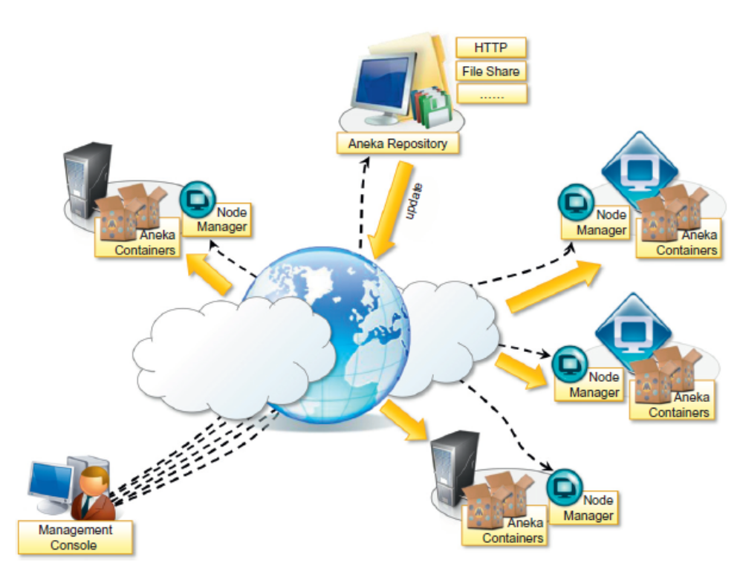
Figure 2.9: Aneka cloud infrastructure overview

Logical organization

The logical organization of Aneka Clouds can be very diverse, since it strongly depends on the con- figuration selected for each of the container instances belonging to the Cloud. The most common scenario is to use a master-worker configuration with separate nodes for storage, as shown in Figure 2.10. The master node features all the services that are most likely to be present in one single copy and that provide the intelligence of the Aneka Cloud. What specifically characterizes a node as a master node is the presence of the Index Service (or Membership Catalogue) configured in master mode; all the other services, except for those that are mandatory, might be present or located in other nodes. A common configuration of the master node is as follows:
- Index Service (master copy)
- Heartbeat Service
- Logging Service
- Reservation Service
- Resource Provisioning Service
- Accounting Service
- Reporting and Monitoring Service
- Scheduling Services for the supported programming models
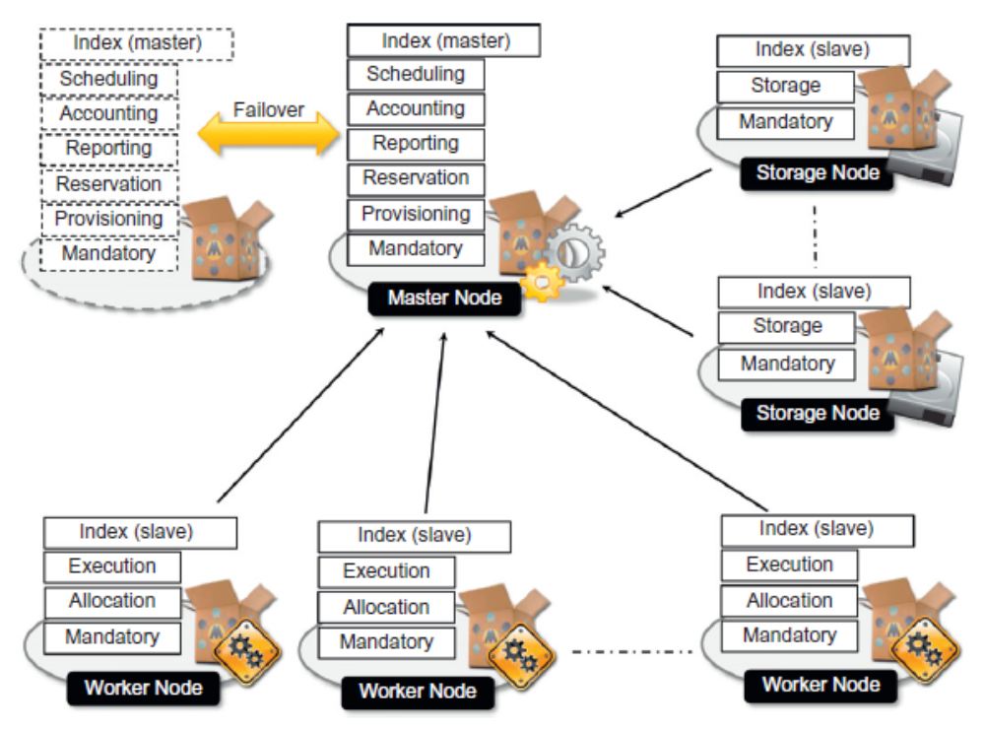
Figure 2.10: Logical organization of Aneka cloud

The master node also provides connection to an RDBMS facility where the state of several services is maintained. For the same reason, all the scheduling services are maintained in the master node. They share the application store that is normally persisted on the RDBMS in order to provide a fault-tolerant infrastructure. The master configuration can then be replicated in several nodes to provide a highly available infrastructure based on the failover mechanism.
The worker nodes constitute the workforce of the Aneka Cloud and are generally configured for the execution of applications. They feature the mandatory services and the specific execution services of each of the supported programming models in the Cloud. A very common configuration is the following:
- Index Service
- Heartbeat Service
- Logging Service
- Allocation Service
- Monitoring Service
- Execution Services for the supported programming models

A different option is to partition the pool of worker nodes with a different selection of execution services in order to balance the load between programming models and reserve some nodes for a specific class of applications. Storage nodes mostly reside on machines that have considerable disk space to accommodate a large quantity of files. The common configuration of a storage node is the following:
- Index Service
- Heartbeat Service
- Logging Service
- Monitoring Service
- Storage Service

Private cloud deployment mode
A private deployment mode is mostly constituted by local physical resources and infrastructure management software providing access to a local pool of nodes, which might be virtualized. In this scenario Aneka Clouds are created by harnessing a heterogeneous pool of resources such has desk- top machines, clusters, or workstations.

These resources can be partitioned into different groups, and Aneka can be configured to leverage these resources according to application needs. Moreover, leveraging the Resource Provisioning Service, it is possible to integrate virtual nodes provisioned from a local resource pool managed by systems such as Xen Server, Eucalyptus, and OpenStack.

Figure 2.11 shows a common deployment for a private Aneka Cloud. This deployment is acceptable for a scenario in which the workload of the system is predictable and a local virtual machine manager can easily address excess capacity demand. Most of the Aneka nodes are constituted of physical nodes with a long lifetime and a static configuration and generally do not need to be reconfigured often.

The different nature of the machines harnessed in a private environment allows for specific policies on resource management and usage that can be accomplished by means of the Reservation Service. For example, desktop machines that are used during the day for office automation can be exploited outside the standard working hours to execute distributed applications.

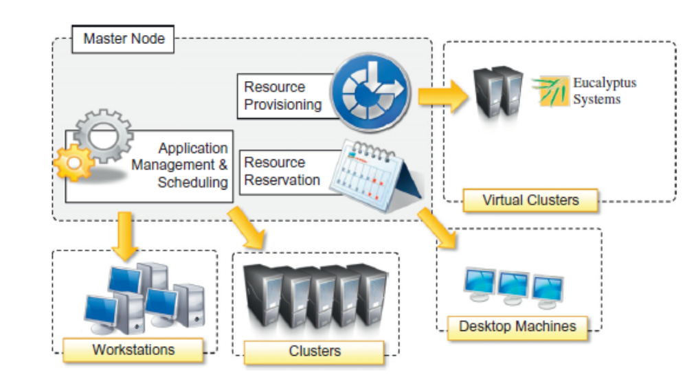
Figure 2.11: Private cloud deployment
Public cloud deployment mode
Public Cloud deployment mode features the installation of Aneka master and worker nodes over a completely virtualized infrastructure that is hosted on the infrastructure of one or more resource providers such as Amazon EC2 or GoGrid. In this case it is possible to have a static deployment where the nodes are provisioned beforehand and used as though they were real machines.

This deployment merely replicates a classic Aneka installation on a physical infrastructure without any dynamic provisioning capability. More interesting is the use of the elastic features of IaaS providers and the creation of a Cloud that is completely dynamic. Figure 2.12 provides an overview of this scenario.
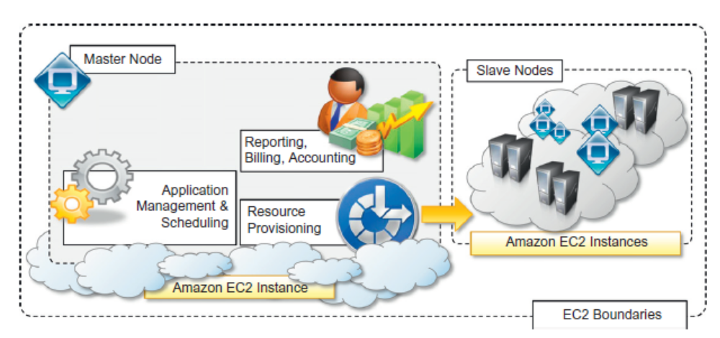
Figure 2.12: Public cloud deployment

The deployment is generally contained within the infrastructure boundaries of a single IaaS provider. The reasons for this are to minimize the data transfer between different providers, which is generally priced at a higher cost, and to have better network performance. In this scenario it is possible to deploy an Aneka Cloud composed of only one node and to completely leverage dynamic provisioning to elastically scale the infrastructure on demand.

A fundamental role is played by the Resource Provisioning Service, which can be configured with different images and templates to instantiate. Other important services that have to be included in the master node are the Accounting and Reporting Services. These provide details about resource utilization by users and applications and are fundamental in a multitenant Cloud where users are billed according to their consumption of Cloud capabilities.

Dynamic instances provisioned on demand will mostly be configured as worker nodes, and, in the specific case of Amazon EC2, different images featuring a different hardware setup can be made available to instantiate worker containers. Applications with specific requirements for computing capacity or memory can provide additional information to the scheduler that will trigger the appropriate provisioning request.

Hybrid cloud deployment model
The hybrid deployment model constitutes the most common deployment of Aneka. In many cases, there is an existing computing infrastructure that can be leveraged to address the computing needs of applications. This infrastructure will constitute the static deployment of Aneka that can be elastically scaled on demand when additional resources are required. An overview of this deployment is presented in Figure 2.13.
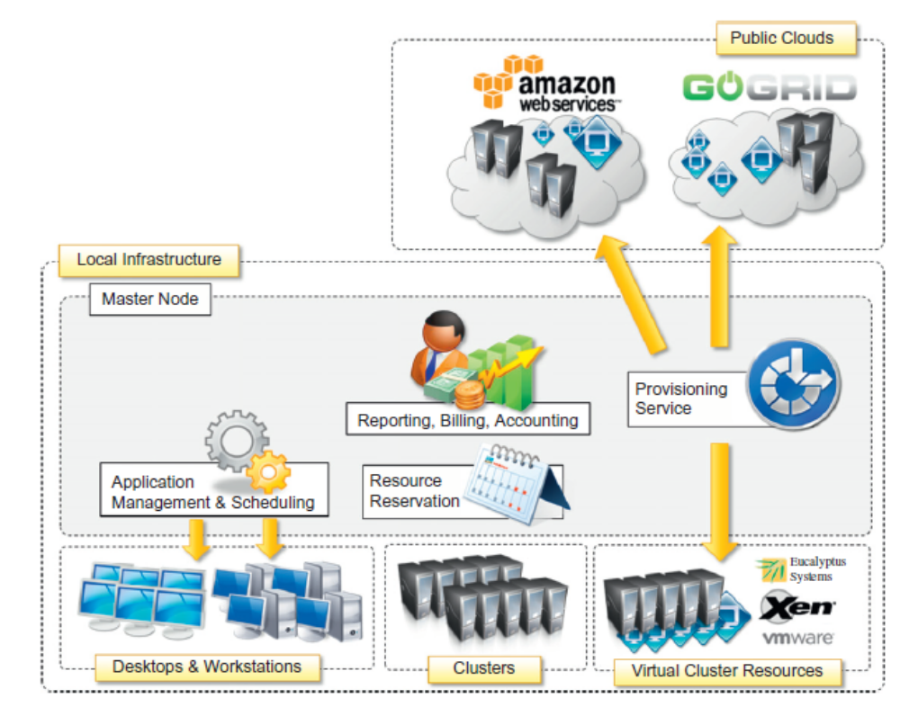
Figure 2.13: Hybrid cloud deployment
This scenario constitutes the most complete deployment for Aneka that is able to leverage all the capabilities of the framework:
- Dynamic Resource Provisioning
- Resource Reservation
- Workload Partitioning
- Accounting, Monitoring, and Reporting

Moreover, if the local premises offer some virtual machine management capabilities, it is possible to provide a very efficient use of resources, thus minimizing the expenditure for application execution. In a hybrid scenario, heterogeneous resources can be used for different purposes. As we discussed in the case of a private cloud deployment, desktop machines can be reserved for low priority work- load outside the common working hours. The majority of the applications will be executed on work- stations and clusters, which are the nodes that are constantly connected to the Aneka Cloud. Any additional computing capability demand can be primarily addressed by the local virtualization facilities, and if more computing power is required, it is possible to leverage external IaaS providers.

Service implemented in Aneka exposes the capability of leveraging several resource pools at the same time and configuring specific policies to select the most appropriate pool for satisfying a provisioning request. These features simplify the development of custom policies that can better serve the needs of a specific hybrid deployment.
Cloud programming and management

Aneka’s primary purpose is to provide a scalable middleware product in which to execute distributed applications. Application development and management constitute the two major features that are exposed to developers and system administrators. To simplify these activities, Aneka provides developers with a comprehensive and extensible set of APIs and administrators with powerful and intuitive management tools. The APIs for development are mostly concentrated in the Aneka SDK; management tools are exposed through the Management Console.

Aneka SDK
Aneka provides APIs for developing applications on top of existing programming models, implementing new programming models, and developing new services to integrate into the Aneka Cloud. The development of applications mostly focuses on the use of existing features and leveraging the services of the middleware, while the implementation of new programming models or new services enriches the features of Aneka. The SDK provides support for both programming models and services by means of the application model and the Service Model. The former covers the development of applications and new programming models; the latter defines the general infrastructure for service development.
Application model
Aneka provides support for distributed execution in the Cloud with the abstraction of programming models. A programming model identifies both the abstraction used by the developers and the runtime support for the execution of programs on top of Aneka. The Application Model represents the minimum set of APIs that is common to all the programming models for representing and programming distributed applications on top of Aneka. This model is further specialized according to the needs and the particular features of each of the programming models.

An overview of the components that define the Aneka Application Model is shown in Figure2.14. Each distributed application running on top of Aneka is an instance of the Application Base, <M>. class, where M identifies the specific type of application manager used to control the application. Application classes constitute the developers’ view of a distributed application on Aneka Clouds, whereas application managers are internal components that interact with Aneka Clouds in order to monitor and control the execution of the application. Application managers are also the first element of specialization of the model and vary according to the specific programming model used.

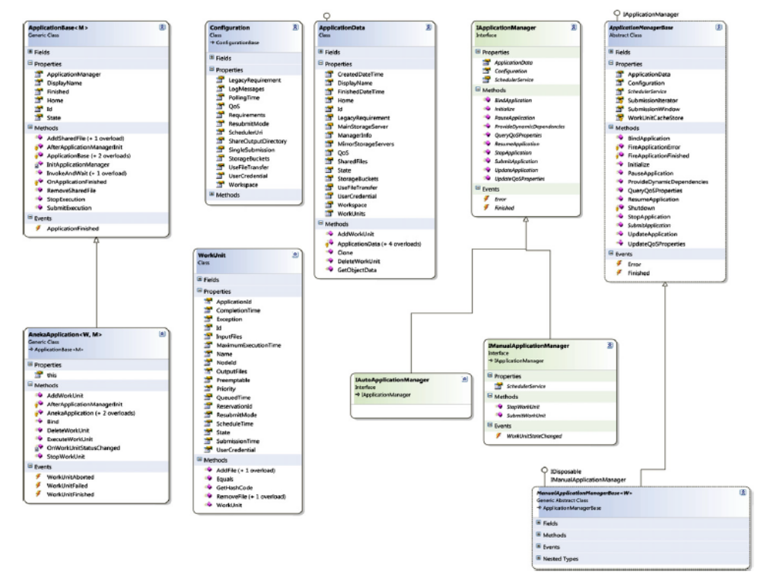
Figure 2.14: The Aneka application model
The first category is the most common and it is used as a reference for several programming models supported by Aneka: the Task Model, the Thread Model, and the Parameter Sweep Model. Applications that fall into this category are composed of a collection of units of work submitted by the user and represented by the Work Unit class. Each unit of work can have input and output files, the transfer of which is transparently managed by the runtime.
The second category covers the case of MapReduce and all those other scenarios in which the units of work are generated by the runtime infrastructure rather than the user. In this case there is no common unit-of-work class used, and the specific classes used by application developers strictly depend on the requirements of the programming model used.

For example, in the case of the MapReduce programming model, developers express their distributed applications in terms of two functions, map and reduce; hence, the MapReduce Application class provides an interface for specifying the Mapper, <K,V> and Reducer, <K,V> types and the input files required by the application. Other programming models might have different requirements and expose different interfaces. For this reason there are no common base types for this category except for Application Base <M>. Where M implements IAutoApplicationManager.

Table 2.1 summarizes the features that are available in the Aneka Application Model and the way they reflect into the supported programming model. The model has been designed to be extensible, and these classes can be used as a starting point to implement a new programming model.

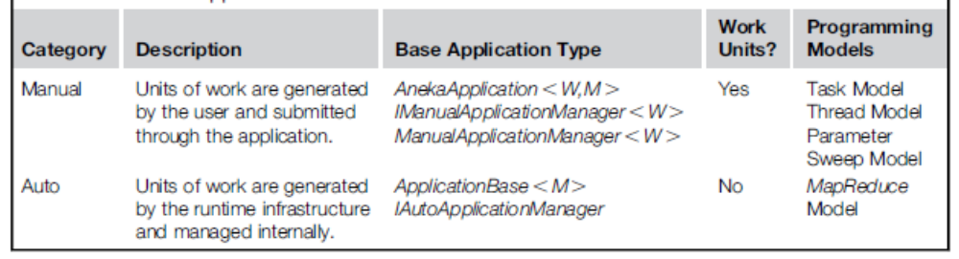
Table 2.1: Aneka’s application model features
For example, the Parameter Sweep Model is a specialization of the Task Model, and it has been implemented in the context of management of applications on Aneka. It is achieved by providing a different interface to end users who just need to define a template task and the parameters that customize it.
Service model
The Aneka Service Model defines the basic requirements to implement a service that can be hosted in an Aneka Cloud. The container defines the runtime environment in which services are hosted. Each service that is hosted in the container must be compliant with the IService interface, which exposes the following methods and properties:
- Name and status
- Control operations such as Start, Stop, Pause, and Continue methods
- Message handling by means of the HandleMessage method
Figure 2.15 describes the reference life cycle of each service instance in the Aneka container. The shaded balloons indicate transient states; the white balloons indicate steady states. A service instance can initially be in the Unknown or Initialized state, a condition that refers to the creation of the service instance by invoking its constructor during the configuration of the container. Once the container is started, it will iteratively call the Start method on each service method.
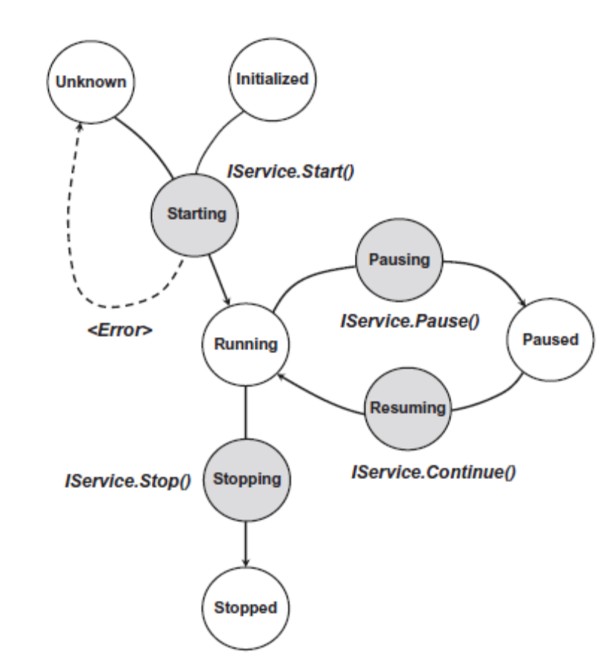
Figure 2.15: Service life cycle
As a result the service instance is expected to be in a Starting state until the startup process is completed, after which it will exhibit the Running state. This is the condition in which the service will last as long as the container is active and running. This is the only state in which the service is able to process messages. If an exception occurs while starting the service, it is expected that the service will fall back to the Unknown state, thus signaling an error.
When a service is running it is possible to pause its activity by calling the Pause method and resume it by calling Continue. As described in the figure, the service moves first into the Pausing state, thus reaching the Paused state. From this state, it moves into the Resuming state while restoring its activity to return to the Running state. Not all the services need to support the pause/continue operations, and the current implementation of the framework does not feature any service with these capabilities.

Aneka provides a default base class for simplifying service implementation and a set of guidelines that service developers should follow to design and implement services that are compliant with Aneka. In particular, the guidelines define a Service Base class that can be further extended to provide a proper implementation. This class is the base class of several services in the framework and provides some built-in features:
- Implementation of the basic properties exposed by IService
- Implementation of the control operations with logging capabilities and state control
- Built-in infrastructure for delivering a service specific client
- Support for service monitoring

Management tools
Aneka is a pure PaaS implementation and requires virtual or physical hardware to be deployed. Hence, infrastructure management, together with facilities for installing logical clouds on such infrastructure, is a fundamental feature of Aneka’s management layer. This layer also includes capabilities for managing services and applications running in the Aneka Cloud.

Infrastructure management
Aneka leverages virtual and physical hardware in order to deploy Aneka Clouds. Virtual hardware is generally managed by means of the Resource Provisioning Service, which acquires resources on demand according to the need of applications, while physical hardware is directly managed by the Administrative Console by leveraging the Aneka management API of the PAL. The management features are mostly concerned with the provisioning of physical hardware and the remote installation of Aneka on the hardware.

Platform management
Infrastructure management provides the basic layer on top of which Aneka Clouds are deployed. The creation of Clouds is orchestrated by deploying a collection of services on the physical infra- structure that allows the installation and the management of containers. A collection of connected containers defines the platform on top of which applications are executed. The features available for platform management are mostly concerned with the logical organization and structure of Aneka Clouds. It is possible to partition the available hardware into several Clouds variably configured for different purposes. Services implement the core features of Aneka Clouds and the management layer exposes operations for some of them, such as Cloud monitoring, resource provisioning and reservation, user management, and application profiling.

Application management
Applications identify the user contribution to the Cloud. The management APIs provide administrators with monitoring and profiling features that help them track the usage of resources and relate them to users and applications. This is an important feature in a cloud computing scenario in which users are billed for their resource usage.
Aneka exposes capabilities for giving summary and detailed information about application execution and resource utilization. All these features are made accessible through the Aneka Cloud Management Studio, which constitutes the main Administrative Console for the Cloud

